## AI ASSISSTED CODING LAB TEST

SET – H , SUBGROUP – H

* Name – G.Sanjansah ,
* Date – 19-09-2025
* Subject – AI Assisted Coding
* Hall Ticket Number – 2503a52l20
* Student Mail Id – 2503a52l20@sru.edu.in

## Subgroup H

### H.1 — [S15H1] Extract hashtags and mentions

Task:

Use regex to extract @mentions and #hashtags (case-insensitive) and return lowercase lists.

Sample Input

Hello @alice check #AI and #Python with @Bob

Sample Output

mentions=['alice','bob'], hashtags=['ai','python']

Acceptance Criteria: Lowercased; ignores punctuation

Screenshots :

CODE :

Output :

### H.2 — [S15H2] Shortest path on weighted graph (Dijkstra)

Task:

Implement Dijkstra from a source node 'A' to all nodes using a priority queue.

Sample Input

{'A':{'B':1,'C':4},'B':{'C':2,'D':5},'C':{'D':1},'D':{}}

Sample Output

{'A':0,'B':1,'C':3,'D':4}

Acceptance Criteria: Correct distances; stable for positive weights

Screenshots :

Prompt :

Code Generated :

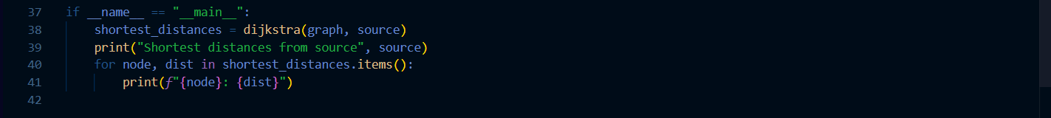

Output :

